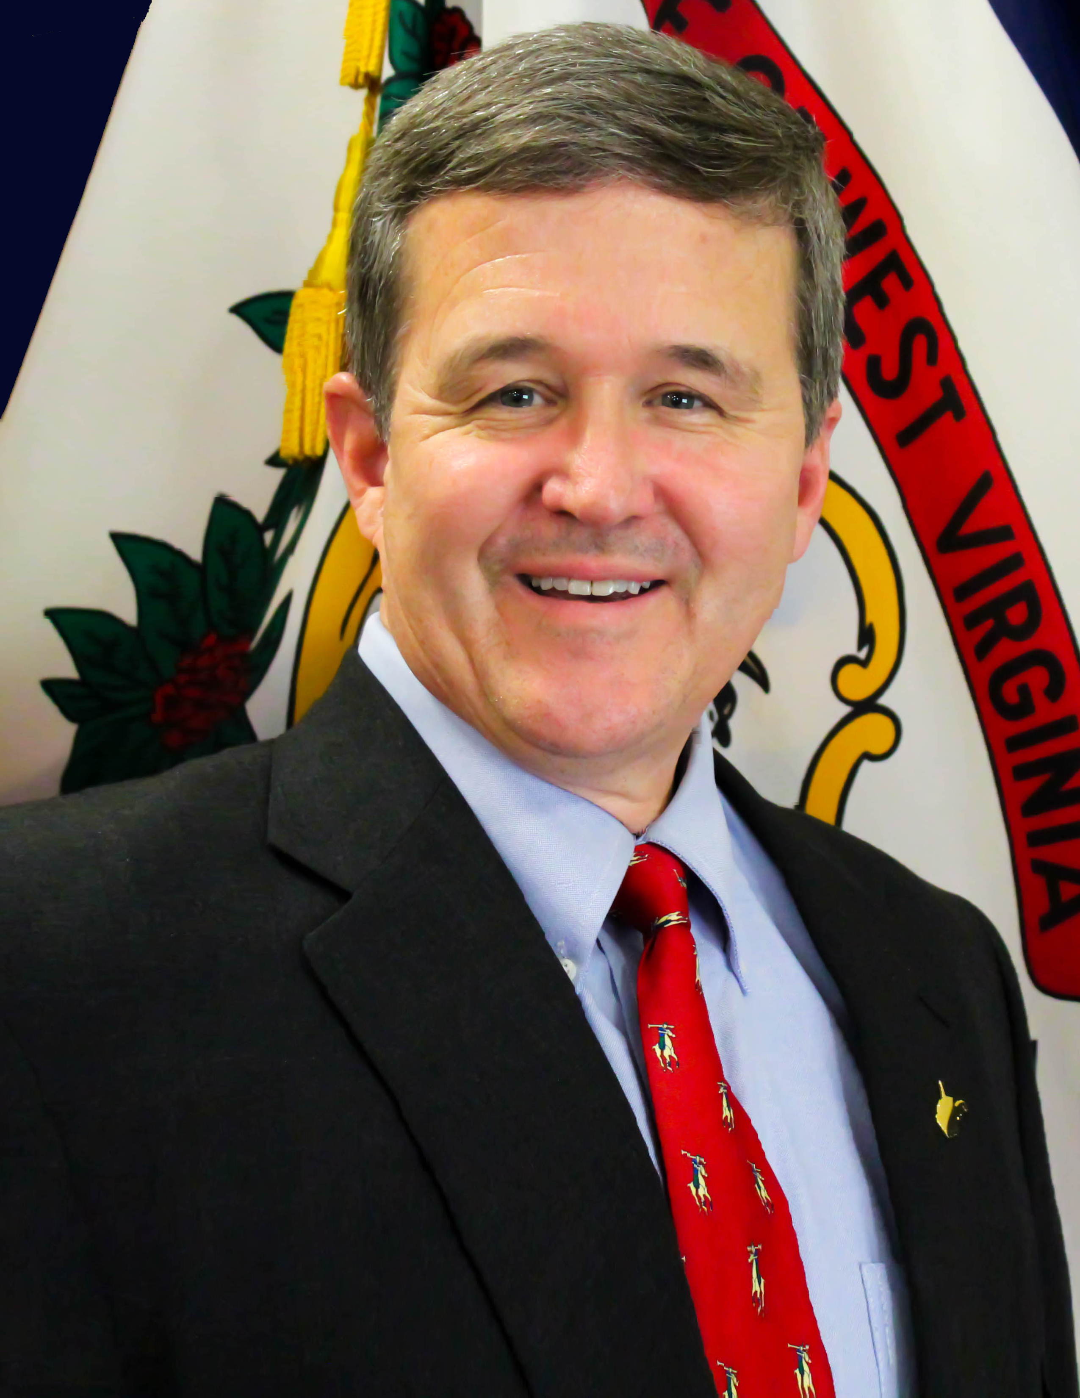
Andrew McCoy "Mac" Warner (R) is West Virginia’s 30th Secretary of State.

Retired from the United States Army, Secretary Warner is a graduate of the United States Military Academy at West Point, a graduate of the West Virginia University School of Law School, and has Master of Law degrees from the University of Virginia Law School and the Army's Judge Advocate General's School.

During his career in the United States Army, Secretary Warner served on four continents, deploying to military hot spots around the world. He held a variety of leadership and teaching positions, culminating as the Chief of International Law for the US Army Europe in Heidelberg, Germany. He also served on the staff at the U.S. Army War College.

After retirement from the Army, Secretary Warner served for five years as a contractor for the U.S. State Department in Afghanistan. There, he served as chief of the Organizational Capacity Building section of the world's largest Rule of Law program. He led over 100 Afghan lawyers, translators and administrative personnel, along with a team of international subject matter experts in advising the Afghan Supreme Court, Attorney General's office, Ministry of Justice, and Ministry of Women's Affairs.

Secretary Warner took his oath of office on January 16, 2017. He quickly went to work focusing on election integrity. Within his first year in office, Secretary Warner and his staff helped county clerks register 46,000 new voters from all 55 counties – an incredible number in a non-election year. Of those new registrations, there were 13,688 high school students registered to vote.

During that same twelve-month period, the Warner administration cleaned up voter rolls by deleting nearly 90,000 deceased, duplicate and improper voter files – which is about 7% of West Virginia’s total registered voter list.

Secretary Warner’s passion for transparent, fair and fraud-free elections has generated a renewed confidence in West Virginia voters and has gained West Virginia national attention as a leader in protecting voter databases and elections systems.
And earlier this month, Secretary Warner and his Business & Licensing team opened the WV One Stop Business Center. This single location houses four state agencies all working together to make business registration quick and convenient. The WV One Stop is believed to be the only four-agency cooperative effort of its kind anywhere in the United States.

Secretary Warner is a sixth generation West Virginian having been born and raised in Kanawha County. The son of the late George ‘Brud’ and Margaret McCoy Warner, he is a graduate of George Washington High School in Charleston.

He and his wife Debbie Law Warner have been married for 35 years, and they raised four children in Monongalia County – all of whom are serving, or have served, in our Armed Forces.

