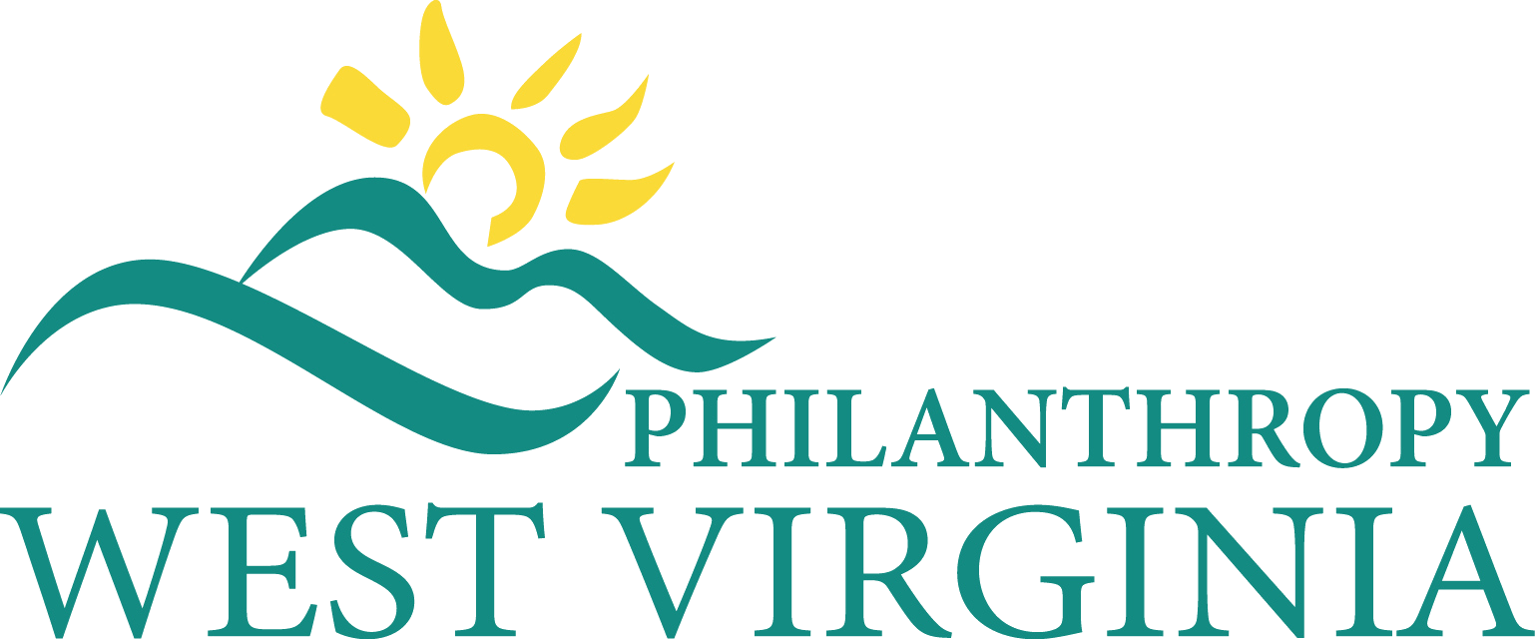

Fourth Quarter Board of Directors Meeting
Friday, December 5, 2025 10 AM – 1:00 PM
Steptoe & Johnson PLLC
4400 White Oaks Blvd., Bridgeport, WV 26330

Join Via Zoom
https://us02web.zoom.us/j/84866040288?pwd=AT66XKNdaq1xWQsrfhstvgeExc3IgQ.1

Meeting ID: 848 6604 0288
Passcode: 196390
View the Meeting Packet:
Board Members: Marian Clowes (Chair), Patty Ryan (Vice-Chair), Mike Lewis (Treasurer), Brock Malcolm (Secretary), Dena Cushman,, Christine Mitchell, David Moran, Elizabeth Pellegrin, Jess Puglisi-Sanders, Mary Ann Raun, Ellen Rossi, Renee Steffen, Lee Storrow
Staff: Jennifer Goddard, Whitney Thompson
AGENDA
Call to Order & Welcome: Board Chair Marian Clowes 10:00 AM
Conflict of Interest Statement Query: Board Chair Marian Clowes
Consent Agenda: Board Chair Marian Clowes
The following items are part of a consent agenda package. Please review them carefully and if you have questions or concerns contact Whitney Thompson at whitney@philanthropywv.org before the meeting.
- Approval of September 19, 2025 BOD Minutes (Exhibit A)
BOARD ACTION: Approval of Consent Agenda

Financial Report: Treasurer Mike Lewis 10:10 AM
- Budget Report & October Financial Statement (Exhibits B and C )
BOARD ACTION: Approval of Finance Committee Report
- 2026 Proposed Budget Review (Exhibit D)
BOARD ACTION: Approval of 2026 Budget

Chairman’s Report: Marian Clowes 10:40 AM

Public Policy Committee Report: David Moran, Chair 10:50 AM

Governance Committee Report: Renee Steffen, Chair 10:55 AM

CEO Report: Jennifer Goddard 11:05 AM
- Membership Update (Exhibit E)
- Fund Development
- Sustainability Campaign Update: Jennifer Goddard
  - Review Fund Development & Sustainability Plan status
  - Philanthropic Partners Program Update (Exhibit F )
- Update on strategic priorities,
- Food Insecurity Convenings
- 2025 Conference Report (Exhibit G)

Proposed 2026 Board of Directors Meeting Dates (all meetings at Steptoe & Johnson in Bridgeport except for Annual Meeting, which is held during the Conference)
- March 20, 2026
- June 12, 2026
- September 18, 2026
- Annual Meeting at Conference in Charleston Oct. 13-15
- December 11, 2026
Additional Dates of Note:
- Philanthropy & Nonprofit Day at the Legislature February 18, 2026
- Foundations on the Hill March 16-19 2026 at The Salamander Hotel, Washington DC
Executive Session 11:30 AM
Adjournment & Lunch 12:00 PM

